**Assignment - 1**

Python Programming

|  |  |
| --- | --- |
| Assignment Date | 19 September 2022 |
| Student Name | Mr. Ashok Kumar A |
| Student Roll Number | 111719205008 |
| Maximum Marks | 2 Marks |

**Question - 1:**

Write Split the String. [s=“Hi there Sam”].

|  |
| --- |
| **Solution:** |
|  | s.split() |
|  | #----------------------------------------# |
|  |  |

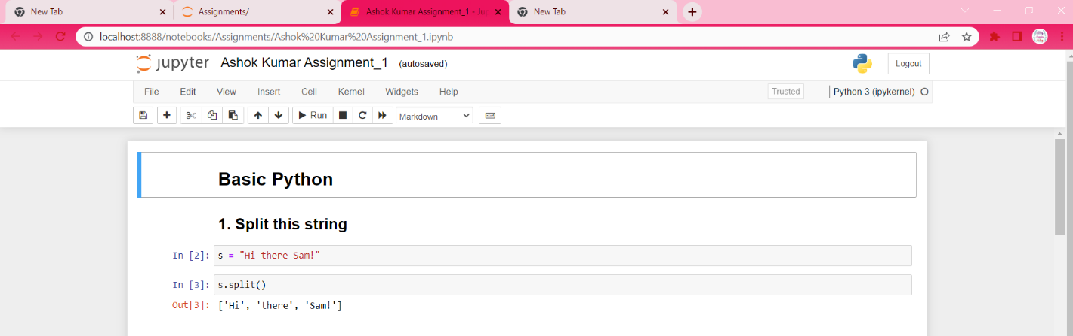

**Question - 2:**

Use .format() to print the following string.

Output should be: The diameter of Earth is 12742 kilometers.

|  |
| --- |
| **Solution:** |
|  | planet = "Earth" |
|  | diameter = 12742 |
|  | print("The diameter of {} is {} kilometers.".format(planet, diameter)) |
|  | #----------------------------------------# |

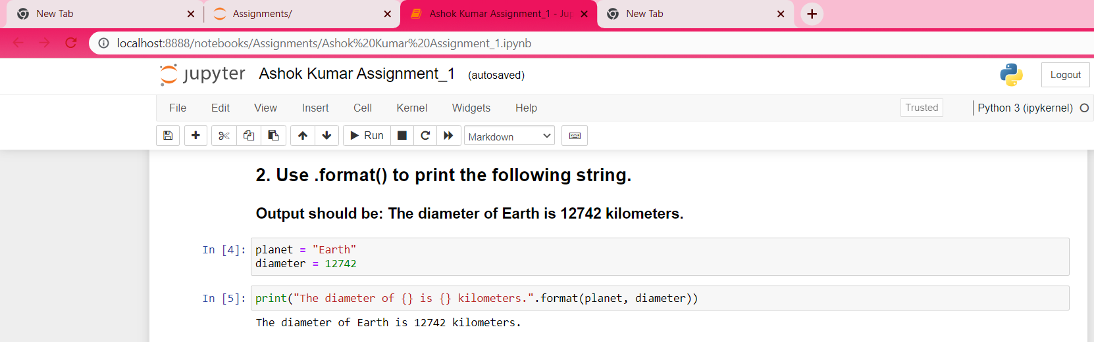

**Question - 3:**

## In this nest dictionary grab the word "hello". d = {'k1':[1,2,3,{'tricky':['oh','man','inception',{'target':[1,2,3,'hello']}]}]}

Solution:

|  |
| --- |
|  |
|  | d['k1'][3]['tricky'][3]['target'][3] |
|  | #----------------------------------------# |
|  |  |
|  |  |
|  |  |

**Question - 4:**

## 4.1 Create an array of 10 zeros.

## 4.2 Create an array of 10 fives.

Solution:

|  |
| --- |
|  |
|  | import numpy as np  array=np.zeros(10) |
|  | print("An array of 10 zeros:") |
|  | array = np.ones(10)*5  print("An array of 5 fives:")  print(array) |
|  | #----------------------------------------# |

**Question - 5:**

## Create an array of all the even integers from 20 to 35.

|  |
| --- |
| **Solution:** |
|  | import numpy as np  np.arange(20,36,2) |
|  | #----------------------------------------# |
|  |  |

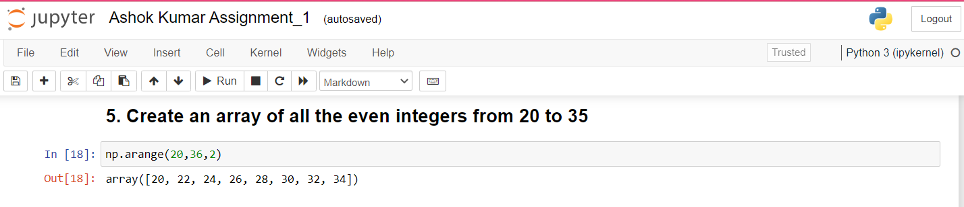

**Question - 6:**

## Create a 3x3 matrix with values ranging from 0 to 8.

|  |
| --- |
| **Solution:** |
|  | import numpy as np  np.arange(0, 9).reshape(3,3) |
|  |  |
|  | #----------------------------------------# |

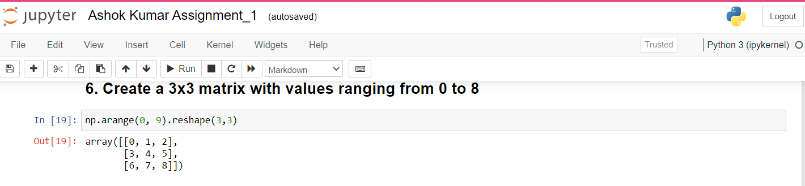

**Question - 7:**

Concatenate a and b

a = np.array([1, 2, 3]), b = np.array([4, 5, 6])

|  |
| --- |
| **Solution:** |
|  | a = np.array([1, 2, 3]) |
|  | b = np.array([4, 5, 6]) |
|  | np.append(a, b) |
|  | #----------------------------------------# |

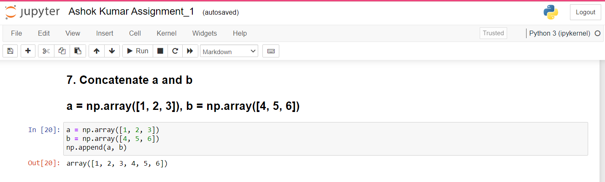

**Question - 8:**

## Create a dataframe with 3 rows and 2 columns

|  |
| --- |
| **Solution:** |
|  | import pandas as pd  data = [['Jack', 18], ['Jill', 20], ['Jane', 21]]    pd.DataFrame(data, columns=['Name', 'Age']) |
|  | #----------------------------------------# |

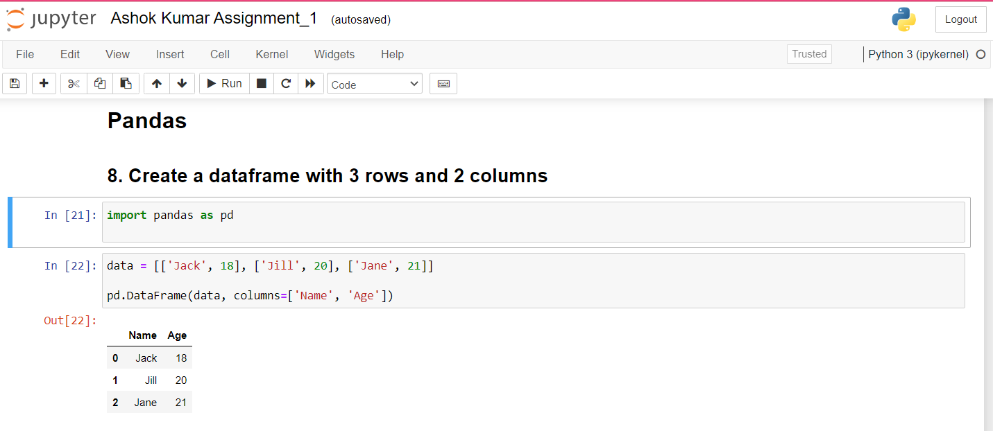

**Question - 9:**

## Generate the series of dates from 1st Jan, 2023 to 10th Feb, 2023.

|  |
| --- |
| **Solution:** |
|  | import pandas as pd  pd.date_range("2023-01-01", periods=41, freq="D") |
|  | #----------------------------------------# |

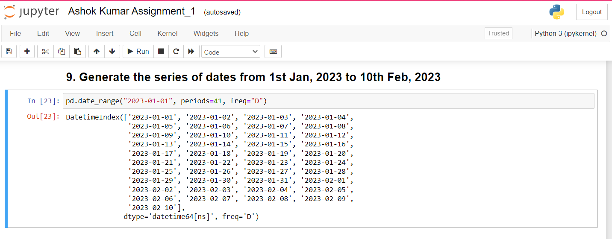

**Question - 10:**

Create 2D list to DataFrame

lists = [[1, 'aaa', 22], [2, 'bbb', 25], [3, 'ccc', 24]].

|  |
| --- |
| **Solution:** |
|  | import pandas as pd  lists = [[1, 'aaa', 22], [2, 'bbb', 25], [3, 'ccc', 24]] |
|  | pd.DataFrame(np.array(lists)) |
|  | #----------------------------------------# |

